ADA 100®

AREA OF RESCUE SYSTEM
VERSION 8.5a

OPERATIONS
&
INSTALLATION MANUAL



HOUSING DEVICES, INC
407R MYSTIC AVE.
MEDFORD, MA 02155
800-392-5200

TABLE OF CONTENTS

INTRODUCTION Page 3

SYSTEM DESCRIPTION Page 4

SYSTEM OPERATION Page 4
MASTER STATION OPERATION Page 4
AREA STATION OPERATION Page 5

SYSTEM CONSTRUCTION Page 5
MASTER STATION INDICATORS & CONTROLS Page 5-6

AREA STATION INDICATORS & CONTROLS Page 6

POWER REQUIREMENTS Page 7

SYSTEM COMPONENTS Page 7
Master Station Page 7
Area Station Page 7
Relay Card Cabinet Page 7
RELAY CARD Page 7
CONTROL BOARD Page 8
Battery Backup System CABINET Page 8
AMPLIFIER Page 8
BRAILLE INSTRUCTIONAL SIGN Page 8
ILLUMINATED AREA STATION SIGN Page 8

INSTALLATION Page 9
UNPACKING Page 9
BACK BOX Page 9
SURFACE MOUNTING COLLAR Page 9
Master Station Page 10
Area Station Page 10
Relay Card Cabinet Page 10
Battery Backup System CABINET Page 10
INSTRUCTIONAL SIGNS Page 10

SYSTEM WIRING AND CONNECTIONS Page 11
General Page 11
Master Station Wiring Page 11
Area Station Wiring Page 11
Relay Card Cabinet Wiring Page 11
Battery BackUp SYSTEM Wiring Page 12
wire & cable legand Page 13

TROUBLE-SHOOTING Page 14-16

APPENDIX WIRING DIAGRAMS Page 17

ADA 100 System Riser Diagram Page 18

ADA-100 Relay Card Cabinet Diagram Page 19

ADA-100 Master Station Riser Diagram Page 20

ADA-100 Dual Master Riser Diagram Page 21

ADA-100 Area Station Connection Diagram Page 22

ADA-100 T 3 9 Connection Diagram Page 23

ADA-100 Battery Backup Riser Diagram Page 24

ADA-100 Master Trouble Light Directions (installing the shunt) Page 25
ADA-100 2001 Phone Dialer Diagram Page 26
ADA-121 RM Strobe Connection Diagram (Master Station & Area Station) Page 27

Introduction

Congratulations on your decision to choose the ADA 100 Area of Rescue System from Housing Devices, Inc. Since the inception of the American with Disabilities Act the ADA 100 has been the superior choice of architects and engineers throughout the U.S.A.

The ADA 100 Area of Rescue System incorporates state of the art design developed from years of actual field experience installing over 10,000 devices at thousands of sites. The ADA 100 is a hard wired system that can be operated independently of any other building systems or interfaced with your existing annunciator or fire alarm system. It is easy to install and designed to provide you with years of trouble free use with virtually no maintenance needed.

The new ADA 100 delivers unparalleled performance with the same superior quality and support that companies throughout the country have come to expect from Housing Devices Inc. 800-392-5200.

System Description

The ADA 100 is a modular, hands-free Area of Refuge System with dual audio and visual alarms and built in supervision capabilities designed to comply with the Americans with Disabilities Act. The ADA 100 Area of Refuge System is a hard wired system needing only a simple connection to AC power and/or auxiliary DC power to operate. The system can be operated independently of any other building systems or interfaced with your existing annunciator or fire alarm system.

Each ADA 100 installation consists of at least one Master Station, one or more Area Stations, Relay Card Cabinet (with one Control Board and one or more Relay Cards, and Battery Backup Power Supply System. Each Master Station and each Area Station are mounted using either a Flush Back Box or Surface Mounting Collar. Tamper Proof hardware and a Tamper Driver (socket only) are also included with each system. Optional system components include Braille Instructional Signs with tactile lettering, Illuminated “Area of Refuge” signs with universal mounting hardware and independent battery backup system (also available without battery backup), telephone dialers (4 number capacity) and remote Area Station mounted strobe lights. (blue, red, & standard white)

System Operation

All conversations are controlled at the Master Station using the specific “TALK” and “LISTEN” metal buttons identified for each Area Station location in the system. Operation of the system is confirmed at both the Master Station and Area Stations by means of audio and visual indicators. These indicators verify to the security attendant that the system is fully operational. They identify locations requesting assistance, alert the security attendant to respond to the request(s) for help from the Area Station location(s), and establish two-way communications. All conversations at the Area Station are “hands-free” after the initial system request.

Master Station Operation
When the system is activated by a request for help from an Area Station, a 90 dbA sound will occur through the Master Station and a steady red LED identified with a specific Area Station location (engraved label) will illuminate. The security attendant operates the system by depressing the metal “TALK” button on the Master Station for each specific Area Station location to establish a dialog with the person in need of help. This will:
- Silence the piezoelectric alarms at both the Master Station and the Area Station
- Illuminate the red LED labeled “HELP COMING” at the Area Station
- Open up a two-way communication channel with the Area Station so that the security attendant can converse with the person requesting help
- Depressing the metal “LISTEN” button at the Master Station enables the security attendant to hear the person’s response

Resetting the system is accomplished by turning the reset key at the Master Station. This will extinguish the “HELP COMING” light(s) at all Area Station(s) and the Master Station.

NOTE: The Talk button must be depressed at each specific Area Station to Listen to that station

EXAMPLE: The attendant is speaking to Area #1 pressing the Talk button if he moves to Area # 3 and presses the Listen button he will still be listing to Area #1

Area Station Operation
Depressing the large 3” “Push for Help” button on the Area Station activates the system. This initiates a request to the Master Station and:
- Sounds the piezoelectric alarms at both the Master Station and the Area Station-
- Illuminates the red LED labeled “HELP REQUESTED” at the Area Station and the red LED corresponding to that specific Area Station at the Master Station
- Enables hands-free two-way communication at the Area Station upon acknowledgement by the security attendant at the Master Station
Resetting the Area Station is accomplished by turning the reset key at the Master Station. This will extinguish the “HELP COMING” LED at the Area Station(s) and the red LED(s) at the Master Station, and return them to the standby mode.

System Construction

All external system panels are constructed using 16 gauge 304 #4 finish (0.062”) stainless steel providing architecturally pleasing design and years of trouble free performance. ADA 100 Master and Area Stations are designed, manufactured, and tested by Housing Devices to ensure the highest standards of system integrity and performance.

System interconnections are accomplished using labeled captive screw “plug-in” connectors to simplify and expedite installation. The system’s independent supervision helps to promote easy trouble-shooting via rapid problem identification and repair. The ADA 100 self-identifies system problems using its supervisory circuits to illuminate amber colored “trouble LEDs” located at the Master Station for each independent Area Station location that is affected.

If a system wide power fault occurs the ADA 100 continues to operate utilizing the battery backup system ensuring continued emergency call system viability and availability, for a minimum of 90 minutes.

Master Station Indicators and Controls

Visual Indicators
The Master Station utilizes red colored SuperBrite® LEDs (one per each Area Station location or “area”) to visually indicate a request for assistance has originated from an Area Station location. The Master Station utilizes amber colored SuperBrite® LEDs (one per each Area Station location or “area”) to visually indicate that a fault has occurred at a particular Area Station(s) or in the wiring between the Master Station and Area Station(s), or if the Master Station has failed.

Audio Indicators
The Master Station utilizes a piezoelectric alarm to generate a 90 dbA signal through the Master Station to aurally indicate to the security attendant that a request for help has been generated. It will remain active until the security attendant at the Master Station initiates a response by depressing the metal “TALK” button on the Master Station.

System Power Indicator
A green colored SuperBrite® LED located directly beneath the system “RESET”.power key switch indicates system power. When the system is operating normally, the LED will be illuminated.

Communication Controls
There are two large (7/16”) flat metal buttons under headings labeled “TALK” and “LISTEN” for each Area Station location in the system. The name of each Area Station location is permanently engraved on the Master Station next to the specific buttons for that location. Optional engraved directories identifying each Area Station are also available to provide for future system growth or changes -without having to power down the system, or to dismantle or exchange the Master Station. These controls are only active when help has been requested from an Area Station location.

Communications from the Master Station may be made to one or more Area Stations at the same time in order to maximize response to emergency situations in the event that they are of a more building wide nature.

System Reset Control
A keyed switch with momentary “RESET” position is provided on the Master Station to reset the entire system following a request(s) for help. The normal position of the key switch is straight up or ON. The ON position of the key switch is the only position in which the key may be removed.

If a fault occurs, the system is designed to stay “on line” and continue to provide emergency call capability from each Area Station without the system needing to be RESET.

Area Station Indicators and Controls

The Area Station communicates directly with the Master Station. Depressing the 3” “Push for Help” button initiates a request for assistance from the Master Station, and permits hands-free (from the Area Station) two-way communications between the Master Station and Area Station(s).

Visual Indicators
The Area Station utilizes two red colored SuperBrite® LEDs to visually indicate that a request for help has been generated from the Area Station location and that the “HELP REQUESTED” LED is acknowledged from a security attendant at the Master Station. Permanently engraved and backfill painted acknowledgement labels (“HELP REQUESTED” and “HELP COMING”) are located next to each LED.

Audio Indicators
The Area Station utilizes a piezoelectric alarm to generate a 90 dbA signal through the Area Station to aurally indicate to the caller that a request for help has been generated. It will remain active until the security attendant at the Master Station initiates a response by depressing the metal “TALK” button on the Master Station.

Communication Controls
A large (3”) domed stainless steel button surface engraved with the words “PUSH FOR HELP” backfill painted in red is used to initiate a request for help from an Area Station.

Power Requirements

The ADA 100 Emergency Call System has an input voltage of 120 VAC, converting to 24VDC @ 1 amp. This connection is made at the systems Relay Card Cabinet houses the system’s electronics.

The ADA 100 Area of Refuge System also features a 24VDC battery backup system supplying 1.0 amp for each group of ten (or multiples of 10) Area Stations to ensure auxiliary power in the event of a power outage. Larger power supplies are included with larger systems.

System Components

Master Station
The Master Station is a 16 gauge 304 #4 finish (0.062) stainless steel vandal resistant unit that is the heart of the system from which all calls are controlled. Each Master Station contains a 90 dbA piezoelectric audio alarm, red, green and amber colored LEDs as visual indicators, a system RESET key switch, and engraving identifying each Area Station location. The size of the standard (1-5 areas) flush mounted Master Station is 11” x 11”. Master Station size depends on the number of Area Stations in the system. Consult the manufacturer for larger Master Station dimensions.

A Master Station can accommodate up to 60 Area Stations. The baseline Master Station accommodates 1-5 Area Stations. The next larger size Master Station accommodates 6-10 Area Stations. The next larger size Master Station accommodates 11-15 Area Stations, then 16-20 Area Stations and so forth, up to 60 Area Stations. Multiple Master Stations may be used to accommodate larger systems. Master Stations should be mounted in an appropriate and secure area (manned location) typically adjacent to other security equipment.

Area Station
Area Stations are 9” x 9” 16 gauge 304 #4 finish (0.062) stainless steel vandal resistant units that are used to communicate directly with the Master Station. Each Area Station features a 90 dbA piezoelectric audio alarm, red colored LEDs as visual indicators and a large (3”) domed stainless steel engraved and backfill red painted panic button labeled “Push for Help”. Area Stations should be mounted in areas where they are visible and easily accessible by anyone needing help.

Relay Card Cabinet
The standard size Relay Card Cabinet (12” x 12” x 4”) holds up to 10 Relay Cards, one per each Area Station in the system. Larger systems will use larger cabinets with more Relay Cards.

Larger cabinets to hold up to 20 relay cards are available (18” x 18” x 4”)

Relay Card
The Relay Card is the electronic brain for an Area Station; one card is supplied & mounted in the Relay Card Cabinet for each Area Station used in the system.

Control Board
The Control Board is located in the Relay Card Cabinet and provides electronic support for the Master Station and Battery Backup System. One Control Board is used per system. Optional K1 relay is available for use as a dry contact.

Battery Backup System Cabinet
The standard Battery Backup System Cabinet houses the components that encompass the Battery Backup System, which provides 24VDC continuous power to the ADA 100 Emergency Call System in the event of a power failure. The system monitors for AC power failure, AC and DC surge suppression, and no/low battery indications. It features auto-resetting overload protection, visual AC and DC power indicators and built-in battery charger circuitry. The system includes two 12VDC sealed lead acid batteries (rated @ 4.5 amp hours each), 1.0 amp battery charger, 24VAC 20VA transformer, and has a continuous output current of 800mA. UL listed Battery Backup Systems are supplied if specified.

Amplifier
The Housing Devices ADA-35 Amplifier, powered by 24VDC, located in the Battery Backup System Cabinet processes the audio communications for the entire system. The audio volume is used to adjust the volume.

Braille Instructional Sign (option)
Satin stainless .0312” laminated to .0625” black plex backplate, helvetica 67 condensed
type red tactile .0312” applique clear raster braille. Four .1875” corner holes .5” to center
of hole. Eased edges. Vertical grain. 5H x 7.25W x .0937D with 4 #10 .75 Tamper wood screws

Illuminated Area Station Sign (option)
An optional illuminated sign with universal mounting hardware, dual face, LED lightning, & Chevron directional knockouts is placed above each Area Station for easy visual identification of the Area Station’s location. Illuminated signs are available with or without their own independent battery backup system.

Installation

Installation of the new ADA 100 Area of Refuge System by Housing Devices, Inc., is simple to accomplish and very straight forward from an installer’s perspective. Newly incorporated PC board technology and the use of plug-in connectors have made installation and expansion quick and easy. The ADA-100 Area of Rescue System provides a solution for security and “Rescue Assistance” requirements. Reviewing and following the below listed recommendations will result in a trouble free installation and years of dependable service.

Unpacking

The ADA 100 alarms, indicator lights, and rugged push buttons are set in vandal proof 16 gauge stainless steel for a lifetime of service and lasting appearance. Although the ADA 100 is designed for long life and durability under difficult conditions, it can be damaged during installation. Please use care in unpacking the system components.

- Equipment cartons damaged during shipping must immediately be reported to the carrier, and also reported to the Manufacturer within 7 days for damage assessment and potential repair
- Prior to handling any electronic components on cold, dry days, the installer shall discharge any collected static electricity to a known ground, in order to prevent damage to the ADA 100 system logic by a static discharge
- Avoid touching board components

Back Box

Flush Back Boxes and installation mounting hardware are ordered from the Manufacturer based on ordering specifications.
- 8” x 8” x 4” deep Back Box rough-in enclosures for the Master Station (1-5 areas) and Area Stations are ordered from the Manufacturer
- Master Station Back Boxes for systems larger than 5 Area Stations will be custom sized based on system specifications. Contact Manufacturer for rough opening dimensions.
- Back Boxes should be mounted solidly in or to the wall using four screws consistent with good engineering practices as established by the EIA and NEC. Refer to ADA requirements for mounting height and placement.
- Attach conduit to Back Boxes (one ¾” knockout is provided). Additional holes may need to be center punched and drilled in the back box to receive conduit.

Surface Mounting Collar
Surface Mounting Collars and installation mounting hardware are ordered from the Manufacturer based on system specifications.
- Master Station (1-5 areas) and Area Station Surface Mounting Collar dimensions are 9 1/4” x 9 1/4” x 2” deep, with two ¾” knockouts.
- Master Station Surface Mounting Collars for systems larger than 5 Area Stations will be custom sized based on system specification.

- Surface Mounting Collars should be mounted solidly to the wall using four screws consistent with good engineering practices as established by the EIA and NEC. Refer to ADA requirements for mounting height and placement.
- Attach conduit to Surface Mounting Collars. Additional holes may need to be center punched and drilled in the Surface Mounting Collar to receive conduit.

Master Station
- Use the four (4) manufacturer supplied Tamper Proof screws to attach the Master Station to the previously installed Back Box or Surface Mounting Collar.
- The Master Station shall be located no farther than 500 feet from the Relay Card Cabinet installation.
- The Master Station cannot be located within 3 feet of a (Fire Alarm Panel, Annuciator, PBX, ect.)
- After making all connections to the Master Station as indicated (see Master Station Hook Up Diagram, Appendix Page 2) slide the unit onto the Back Box or Surface Mounting Collar and attach with the four (4) Tamper Proof screws provided.

Area Station
- Use the four (4) manufacturer supplied Tamper Proof screws to attach the Area Station to the previously installed Back Box or Surface Mounting Collar.
- The Area Station shall be located no farther than 2,000 feet from the Relay Card Cabinet installation.
- 3. The Area Station cannot be located within 3 feet of a (Fire Alarm Panel, Annuciator, PBX, ect.)

4. After making all connections to the Area Station as indicated (see Area Station
Hook Up Diagram, Appendix Page 3) mount the unit onto the Back Box or Surface Mounting Collar and attach with the four (4) Tamper Proof screws provided.

Relay Card Cabinet
- Use four (4) screws to attach the Relay Card Cabinet to a solid surface in a secure location (typically the electrical or telephone room).
- See Relay Card Cabinet Hook Up Diagram, Appendix Page 4.

- The Relay Card Cabinet cannot be located within 3 feet of a (Fire Alarm Panel, Annuciator, PBX, ect.)

Battery Backup System Cabinet
- Use four (4) screws to attach the Battery Backup System Cabinet to a solid surface in a secure location (typically the electrical or telephone room).
- See Battery Backup Hook Up Diagram, Appendix Page 5.
- The Battery Back-up Cabinet cannot be located within 3 feet of a (Fire Alarm Panel, Annuciator, PBX, ect.) Instructional Signs (option)
- Braille Instructional Sign: Use four (4) Tamper Proof wood screws provided) to attach each Instructional Sign next to the Area Station.
- Illuminated Sign: Use provided universal mounting hardware to locate above each Area Station.

SYSTEM WIRING AND CONNECTIONS

General
HDI suggests on the first power-up, to have 1 zone connected and this is accomplished by removing the gray ribbon cable between the 1st relay card and the 2nd relay card in the RELAY CARD CABINET, by doing this the rest of the system area stations are offline.

- Install all conduit for the Master Station, Area Stations, Relay Card Cabinet, and Battery Backup System Cabinet. Conduit shall also be installed for the power to the Battery Backup System Cabinet. Consult the ADA 100 System Riser Diagram Page 18 for connections.
- Make sure wiring shields are connected ONLY at the BATTERY BACKUP SYSTEM CABINET to prevent “Ground Loops”. Tie all shields to a secure ground (connected to “Earth Ground” in a manner consistent with safety and code requirements).

Master Station Wiring
- The Master Station shall be interconnected to each Area Station and all other system components in conduit or surface metal raceway where exposed.
- The Master Station shall be mounted no CLOSER than 3 FT. to other electrical equipment.
- Wiring shall be 3 twisted pair # 1conductor 20AWG with overall shield plus three (3) additional conductors per each Area Station. (See wire and cable legend page #13). Part #HDI ADA-S
- Make sure shields are clipped short and insulated with electrical tape to prevent possible accidental conduction. Consult the Master Station Riser Diagram, Page 20, for proper connections.

Area Station Wiring
- Each Area Station shall be interconnected in conduit or surface metal raceway where exposed. Raceways and conduit shall be protected from water and excess moisture.
- Conduit placement shall be separate from other circuitry to minimize interference with ADA 100 audio communications (e.g., fluorescent lighting).
- Each Area Station will be connected with One 3 twisted pair 1 conductor #20AWG with overall shield. Part # HDI ADA-S
- Make sure shields are clipped short and insulated with electrical tape to prevent possible accidental conduction. Consult the Area Station Connection Diagram, Page 22, for proper connections.

Relay Card Cabinet Wiring
- The Relay Card Cabinet shall be mounted to a wall with the Control Board in the upper left hand side of the cabinet with the door opening from right to left.
- The Relay Card Cabinet shall be interconnected to each system component in conduit or surface metal raceway where exposed.
- **Wiring shall be 3 twisted pair 1 conductor #20AWG with overall shield. Part # HDI ADA-S, Make sure shields are clipped short and insulated with electrical tape to prevent possible accidental conduction. Consult the Relay Card Cabinet Diagram, Page 19, for proper connections.**

Battery Backup System Wiring
- The Battery Backup System shall be interconnected to each system component in conduit or surface metal raceway where exposed. (ONLY CONNECT TO A DEDICATED AC CIRCUIT).
- Wiring shall be 3 twisted pair 1 conductor #20AWG with overall shield. Part# HDI ADA-S
- Make sure wiring shields are connected ONLY at the BATTERY BACKUP SYSTEM CABINET to prevent “Ground Loops”. Tie all shields to a secure ground clip which is connected to “Earth Ground” in a manner consistent with safety and code requirements.

- Consult the ADA-100 Battery Back Up Riser Diagram, Page 24, for proper connections. Please use care during installation as improper installation may void the warranty.

- Select the DC setting on a “Multi meter” and check to see that DC power is present at the Relay Card Cabinet Control Board Terminals 1 and 2, by measuring across Control Board Terminal 1 and Control Board Terminal 2 at the same time. The meter should read +24VDC (standard operating power) throughout the ADA 100 Emergency Call System.

S

UL Listed Battery Backup
- Follow wiring connections in the ACS-2000 (HDI-ADA-BBU-UL) manual for 110 AC connections
- Please refer to ADA-100 Battery Back Up Riser Diagram Page 24 of the wiring section for DC connections.

TYPICAL ADA® 100 Three Zone System

HDI-ADA-100A
HDI-ADAMS5
RESET
POWER
TALK LISTEN TTROUBLE

1ST FLOOR

NORTH
1ST FLOOR

SOUTH

2ND FLOOR
NORTH

2ND FLOOR
SOUTH

ELEV LOBBY

HELP REQUESTED
Note 2
HELP COMING

PUSH

FOR

HELP

Note 3
Note 5

HDI-ADA-100A

HDI-ADA-RCC10

1ea. HDI-ADA-CB
3 ea. HDI-ADA-ARC

HELP REQUESTED
HELP COMING
Note 3

PUSH

FOR

PUSH

FOR

HELP

HELP

Note 3
HDI-ADA-100A
Note 4

HDI-ADA-BBU

1ea. HDI-ADA-35
1ea. HDI-ADA-PS
1ea. HDI-CHARGER
2ea. 12volt 4amp/hr battery

HELP REQUESTED
HELP COMING

PUSH

FOR

PUSH

FOR

HELP

HELP

Note 1

WIRE & CABLE LEGEND
Note 1
Three (3) #14 AWG wires for 120VAC power from a dedicated emergency power branch circuit.
Note 2
One (1) 7 conductor UL Listed and Rated Type CMP or FPLP, Multi-Pair Overall Shielded + 1 Conductor Non-Shielded Plenum Cable. 20 AWG 3 Pair + 1 Conductor 3 Pair Overall Shielded + 1 Conductor Non-Shielded Plenum. Part # HDI ADA-S

One (1) 7 conductor Part # HDI ADA-S, from each HDI-ADA-100A to the HDI-ADA-RCC10.
Note 3

One (1) 7 conductor Part # HDI ADA-S, from the HDI-ADA-BBU to the HDI-ADA-RCC10.
Note 4
Three (3) #20 AWG conductors from the HDI-ADA-RCC10 to the HDI- ADAMS5 for each HDI-ADA-100A in the system. (For the T 3 9 connection at the HDI-ADAMS5)
Note 5

PUSH
FOR
HELP

PUSH
FOR
HELP

PUSH
FOR
HELP
Master Station
Area Station

HELP REQUESTED
HELP COMING

FOR

Relay Card Cabinet
Relay Cards
Control Board
with

TROUBLE SHOOTING

GENERAL
HDI suggests on the first power-up, to have 1 zone connected and this is accomplished by removing the gray ribbon cable between the 1st relay card J1 and the 2nd relay card J2 in the RELAY CARD CABINET, by doing this the rest of the system area stations are offline.

Using the ADA 100 System Riser Diagram, see Page 18, verify that all wiring between each of the ADA 100 Area of Rescue System components has been wired as shown, Power up the System. The System is operating normally when the green LED (on the Master Station) is illuminated and no yellow or red LEDs are illuminated. If the green LED (on the Master Station) is not illuminated, and/or 1 or more yellow or red LEDs are illuminated, then there is a fault in the System. Verify that the System wiring is correct and if there is still a problem, please reference the following problem specific procedures.

NOTE: When 1 area station is working correctly the common equipment in the system (Battery Back-up, ADA-35, Master Station, Control Board) are working correctly and any other Area Stations that aren’t working is likely because of incorrect wiring between the Relay Card & the Area Station.

Basic Trouble Shooting

Problem | Possible Cause & Fixes
Green Power LED is not illuminated | - Check to see that DC power is present at the Relay Card Cabinet Control Board Terminals (1 positive) and (2 negative). The meter should read 24vdc to 27vdc (standard operating power).  - Check to see that DC power is present at the Battery Backup System output Terminals (+) and (-). The meter should read 24vdc to 27vdc (standard operating power).  - Check to see that DC power is present at the 7 pin Master Station Terminals (1 positive) and (2 negative). The meter should read 24vdc to 27vdc (standard operating power).
Red LED will not illuminate or stays on constantly | - The T, 3, 9 Connector on the back of the Master is loose or wired incorrectly.  - The 3, 9 wires from the relay card could be shorted or wired incorrectly.  - Check the ribbon cables on the relay cards.
Amber TROUBLE  LED Is Illuminated  See page 25  CONTINUED TO PAGE 14  CONTINUED FROM PAGE 13 | - Visually inspect the 3 pin terminal block at the Master Station T, 3, 9. The Relay Card Cabinet white terminal block, and Area Station (T) connection for a good electrical connection (confirming continuity) at each location (Master Station, Relay Card Cabinet and Area Station). The T wire from the area station should connect straight through to the T on the master station. See Master Station Hook Diagram, Appendix Page 2.  - If the amber LED is illuminated and no Area station is used in the system (example. You have a five zone master and only using it as a 2 zone system) Beside the 3 pin terminal block on the Master Station  - (T,3,9) the two pin header needs to be shorted, use the small black-  -shunts supplied from the factory included in with the hardware bag.  - If the amber LED continues to stay illuminated after completing step 2 call the Manufacturer.  Note: This is a common negative ( - ) loop used to monitor system “Trouble” (amber LED’s on the Master Station) status for breaks in continuity throughout the ADA 100 system. If one or more Area Stations break continuity (e.g., bad connection, wire cut, etc.) the amber LED will illuminate for that specific Area Station(s) location.
Piezo Alarm is not sounding at the Master station | - Check to see that DC power is present at the Master Station 7 pin connector by measuring across CB7 (+) 24vdc ( - ) at the same time. When the system is in alarm. The meter should read 22vdc to 27vdc. If voltage is present the Piezo alarm buzzer is defective and contact the factory for a replacement.  2. If no voltage is present go back to the (Green LED at the Master Station  does not illuminate) problem in the troubleshooting guide and follow the  instructions to check for the correct voltages.  3. Put the system in alarm and check to see if the Area Station Help  Requested LED is illuminated. If it isn’t and the Help Coming LED is  illuminated check to make sure the Master Station TALK buttons are not  depressed or shorted on the PC board side (check for a short between the  solder lugs of the talk buttons (ALL THE BUTTONS SHOULD BE OPEN)  4. Put the system in alarm and check to see if the Area Station Help  Requested LED is illuminated. If it isn’t and the Help Coming LED is  Illuminated. Replace the SCR chip at the Relay Card (The SCR chip can  be found in the hardware bag included with the system) Please be aware of the position of the SCR before removal.  NOTE: POWER SYSTEM DOWN BEFORE REPLACING SCR  BEFORE REPLACING THE SCR PLEASE BE AWARE THE CHIP WAS SHORTED OUT BY INCORRECT OR SHORTED WIRING FROM THE AREA STATION TO THE RELAY CARD CHECK YOUR WIRING BEFORE POWERING THE SYSTEM BACK ON
Noise or Feedback  Ribbon Cables  Area Station  Terminal Block Layout  See Page 22  In the wiring diagram section | - Check (adjust) audio volume control located on the system’s ADA-35 amplifier found in the Battery Backup Cabinet.  - If the shields are taped at one end & connected to a ground, check the ground for noise, if noise is found disconnect the shields and tape back both ends.  - Disconnect the AC from the system and run the system on Battery Back-up DC, if the noise goes away you have a dirty AC line or something else is on the circuit. (example: fire alarm panel, access control system, PBX .) NOTE: The ADA-100 needs a dedicated AC circuit.  - Check for installation of AC lines, Fire Alarm Panel, or any other electrical systems that could have a supervision circuit or stray AC running within 5 ft. of the Master Station.  - The ADA-100 relay card cabinet has 2 different kinds of ribbon cables.  - The ribbon cable that has a twist at one end can only be used when connecting relay cards up and down (VERTICAL) from J1 to J2  - The ribbon cable that has no twists on either end & is a little longer, can only used when connecting relay cards from row to row or (HORIZONTAL) from either J1 to J1 or J2 to J2  Area Station Pins:  1 (-) One side of the switches  2 (+) One side of the switches  4 Help Requested LED (+)  5 Help Coming LED (+)  7 One side of the speaker (+)  8 One side of the speaker (-)  T (-) for all of the components on the area station  A short should be read across 1 and T at the area station and the relay card cabinet.  Pins 1&2 at the relay card can be shorted to put the system in alarm. (short out the PFH button any one of the 4 pushbuttons at the area station)  Pins 7&8 at the relay card and area station should read 45 ohms. (check for 45 ohm at the area station speaker)  Pins 1&4 on the area station should read the same voltage that is on the Control board 1&2 when help requested is lit and the piezo is on.  Pins 1&5on the area station should read the same voltage that is on the Control board 1&2 when help Coming is lit and the piezo is off.

APPENDIX

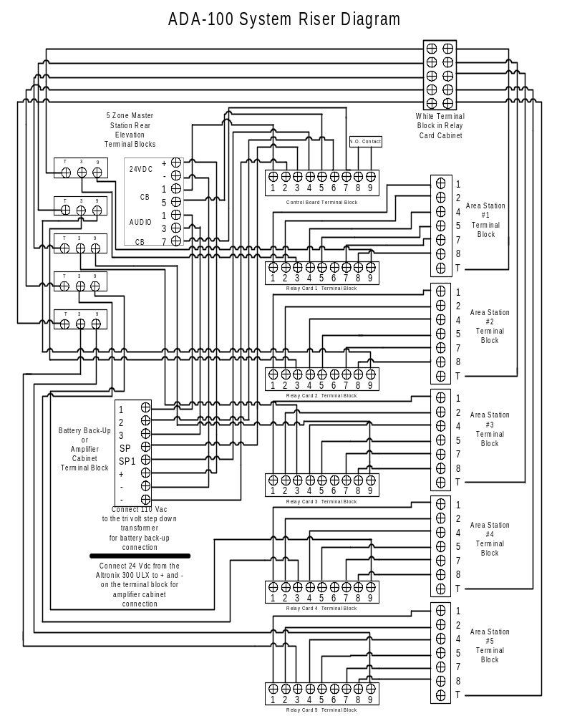
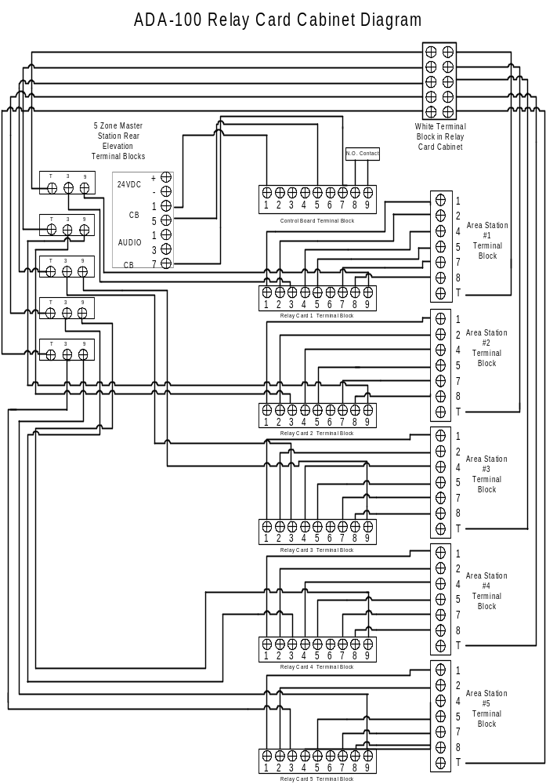

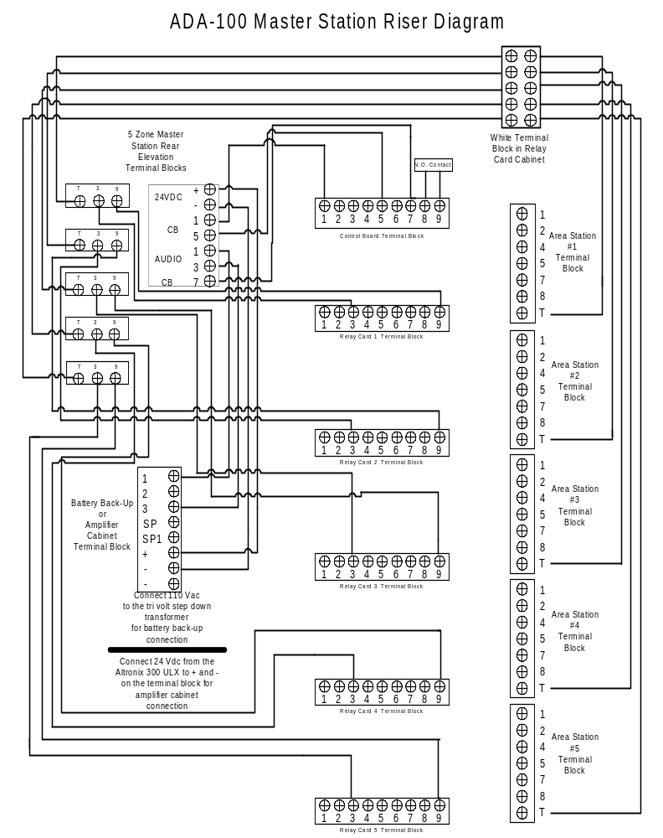

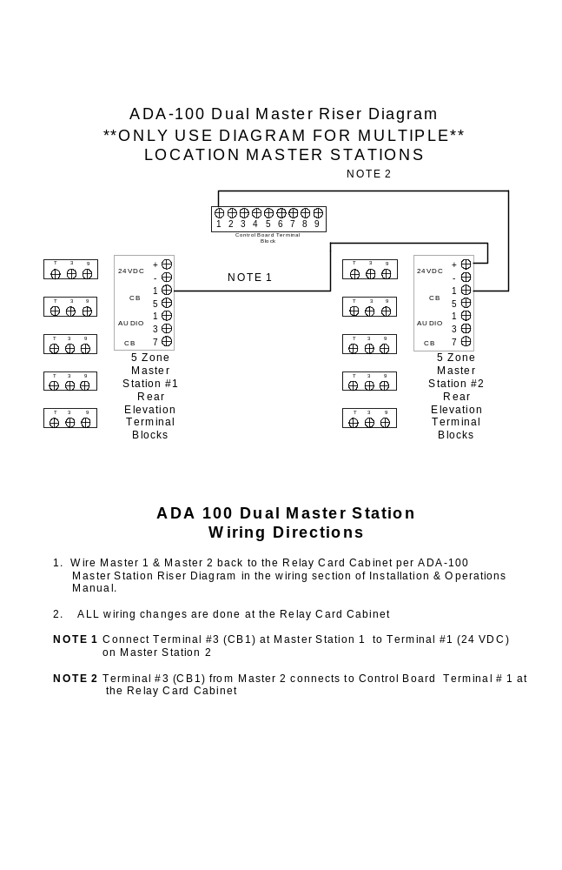

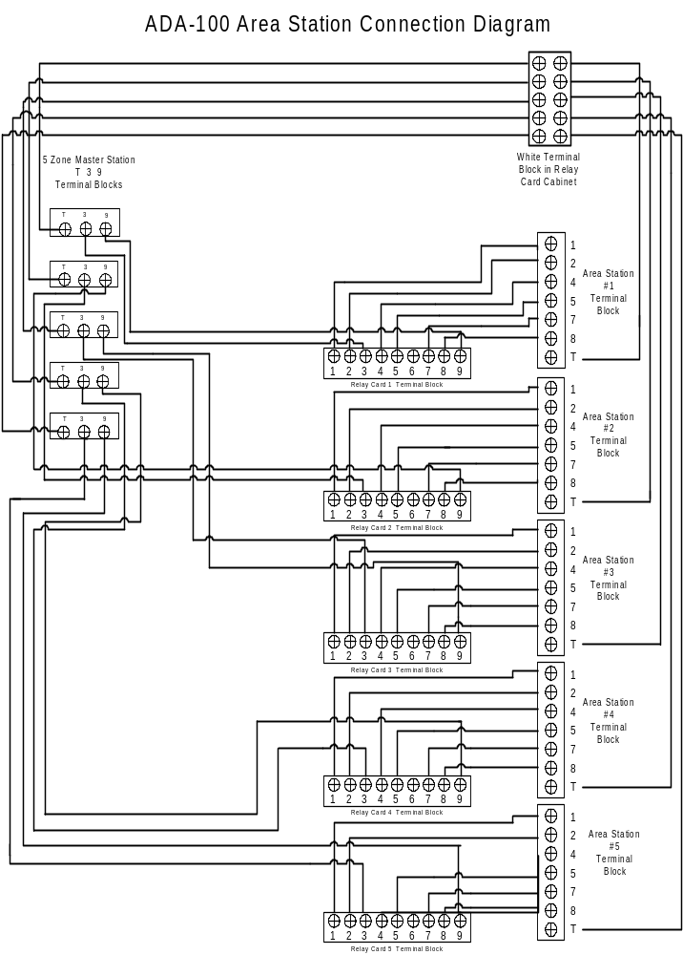

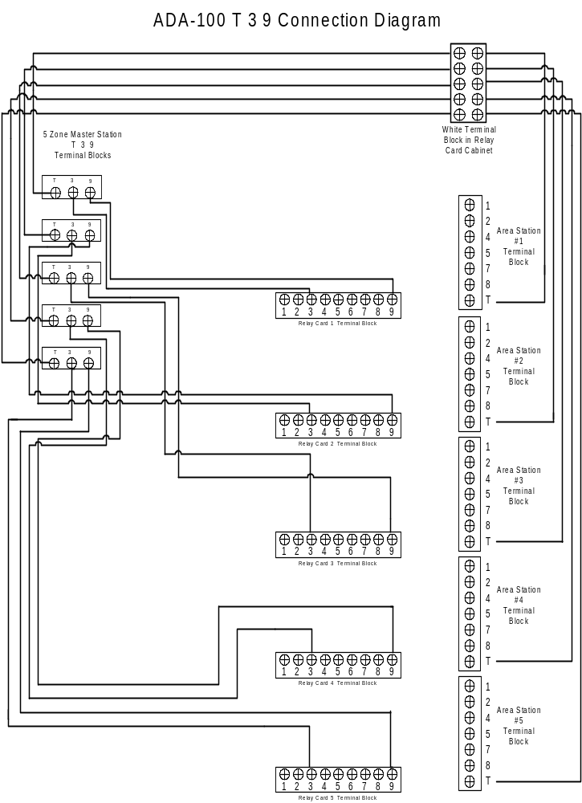
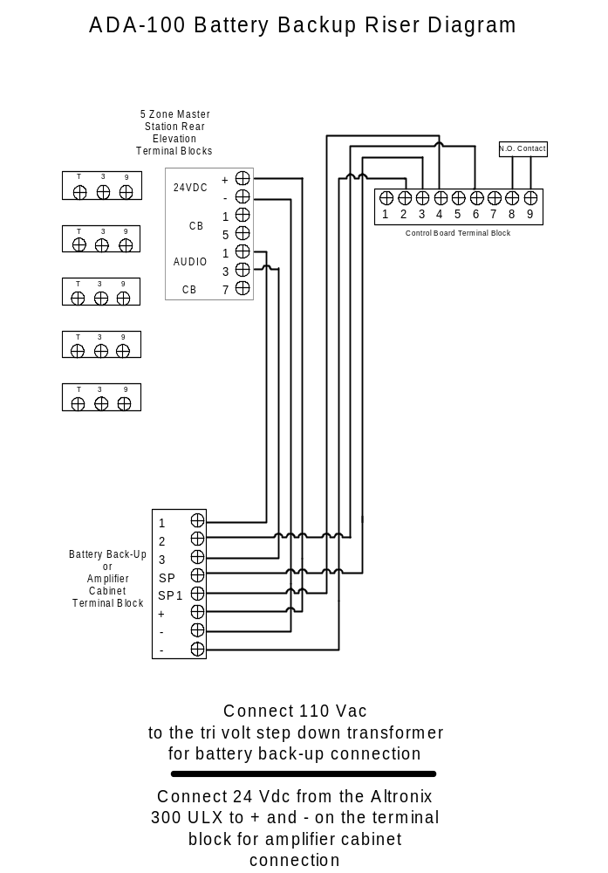
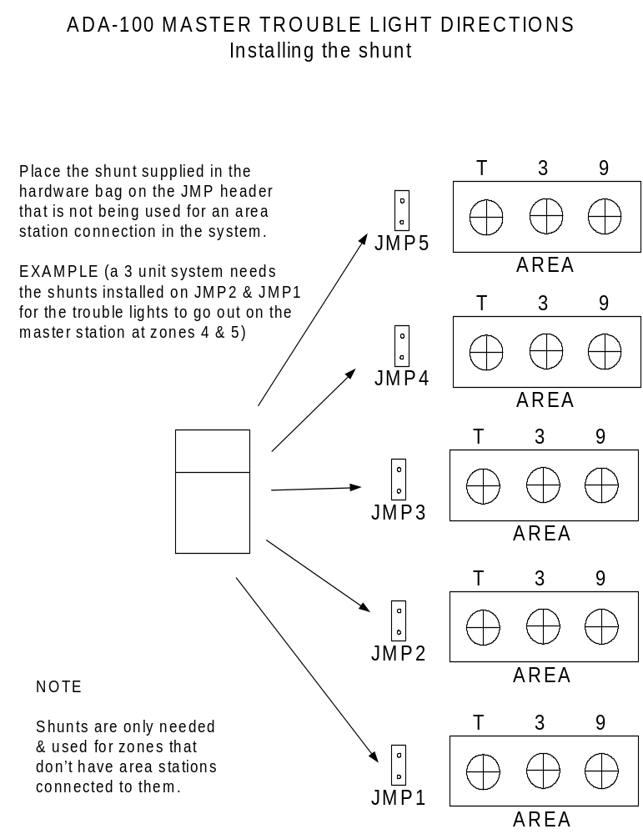
SHUNT


